Harvest for Hunger 2020

Current times are different in so many ways, but hunger within our community persists. Please help us continue to serve those who are food insecure. Our Annual Harvest for Hunger will begin on October 18 and continue to November 22, which will be Dedication Day. This year we are in need of food item donations as well as monetary donations, as we are continuing to stock our outside Blessings Boxes with food items as well as purchasing food vouchers at City Meats grocery store in Woodlawn for our community clients to obtain substantial food quarterly. Each voucher costs IPC $45 and the pictures below show the total amount of food each voucher buys.
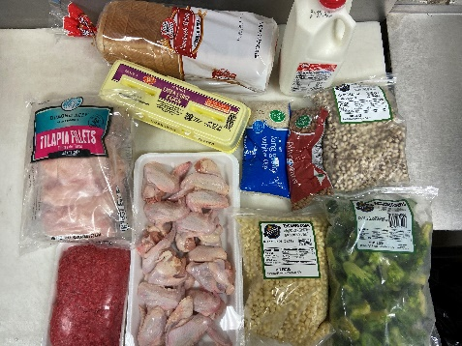
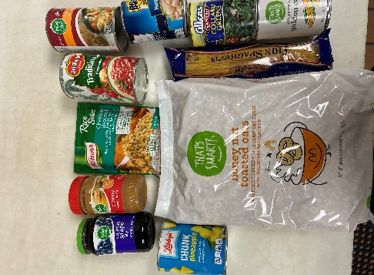
Blessings Boxes Items Needed:

FOOD

Cereal
Canned Meats (Chicken, tuna, salmon, Vienna sausages, Beanie Weanies, Spam)
Powdered Milk
Canned Vegetables

Spaghetti & Sauce
Hearty Soups
Breakfast/Protein Bars
Quick Oatmeal & Grits
Peanut Butter & Jelly
Canned Fruit & Fruit Cups
Diced/Stewed Tomatoes
Chef Boyardee Cans (Spaghetti& Meatballs, etc.)
Pasta

There will be Harvest for Hunger bags available for pickup at IPC during the dates above in which you can put your purchased items and drop them off during this time. Checks should be made to IPC and note Harvest for Hunger in the memo line. Online donations may be made on the IPC website by clicking on Give and choosing Food Pantry in the dropdown.
Please consider participating in Harvest for Hunger this year!

